Working Paper Series

Working Paper Number 1

The Role of Creative Methods in Re-defining the Impact Agenda
Mihaela Kelemen and Lindsay Hamilton
CASIC, Keele University, October 2015
Library Catalogue Reference: CWPS0001

Published by: Community Animation and Social Innovation Centre (CASIC)
Faculty of Humanities and Social Sciences, Keele University,
Keele, Staffordshire, ST5 5BG
Tel: +44 (0)1782 732000
Email: support.casic@keele.ac.uk or for information on the
Working Papers Series l.hamilton@keele.ac.uk
Web: www.keele.ac.uk/casic

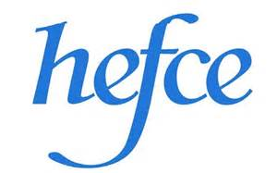

THE ROLE OF CREATIVE METHODS IN RE-DEFINING THE IMPACT AGENDA

Mihaela Kelemen, Keele University

Lindsay Hamilton, Keele University

This working paper makes a contribution to the evolving debate on ‘academic impact’ by focussing on cultural animation, a recent innovation in qualitative methodology and a means by which the division between academic and common-sense knowledge can be transcended. We explain and discuss this process with a first-hand account of the establishment of a new research centre (CASIC-Community Animation and Social Innovation Centre) which is pioneering this and other new and impactful forms of social research. We make two arguments: first, that cultural animation presents a novel platform for engagements between scholars, practitioners and community members and helps re-conceptualise what is meant by academic method, expertise and knowledge. Second, that it offers researchers a practical way of managing the co-production of knowledge, disassembling some of the inherent/inevitable power imbalances between ‘researchers’ and ‘subjects’. Drawing on Pettigrew’s (2011) definition of impact, we argue that spaces such as CASIC enable academics to harness creativity to potentially powerful effects within communities which makes a significant contribution to the ways in which impact is considered.

Keywords: Methods, Network, Co-creation, Democracy, Impact, Legacy

Introduction

Assessing the influence of ideas, theories and concepts beyond academia is of major contemporary significance as part of the ‘impact debate’ (Briggle, et al, 2015; Travers, 2009; Wiles et al, 2013). Embedded in current UK Government funding policy is a strong emphasis placed upon the ways in which research-related skills might benefit individuals, organisations and nations outside the academy (Durose et al, 2014). ‘Impact’ is not a new policy buzzword, however, as almost 20 years ago the ESRC paper 'Building Partnerships' argued that funding bodies should judge research relevance alongside research quality. Yet recent experience in the UK of the funding exercise, REF (Research Excellence Framework), has shed light on new challenges for academics seeking to meet the criteria for impact excellence; for example, it has not been sufficient for researchers to focus on activities and textual outputs that disseminate findings - activities such as staging a conference or publishing a report. The agenda has now moved towards proving the importance of ideas in ‘real world’ scenarios. Indeed, Andrew Pettigrew’s call for ‘Scholarship with impact’ (2011) has been fully embraced by the recent REF. Thus, during the process of preparing for REF 2014, researchers were required to adopt a case-study approach to demonstrate impact in terms of 'an effect/change/benefit to the economy, society, culture, public policy or services, health, the environment or quality of life, beyond academia' (REF Assessment Framework, 2011).
The measurement of impact in such terms poses a practical and intellectual challenge for researchers. It is understandably problematic, for example, for those in time-consuming research and engagement roles to switch to ‘production’ roles as authors of case-studies. Understandably, then, within this demanding climate, some scholars have been vocal about the potential for clash between measures of ‘evidence’, academic integrity and commerciality. How, they argue, can one truly measure the impact of any idea, theory or finding within the confines of the current funding model? Work/time management issues aside, there has also been criticism of the ways in which discourses surrounding impact have tended to reinforce the traditional direction of travel: that is, the export of knowledge from university faculty to the world ‘out there’. In other words, some claim that the very terminology of ‘impact’ is suggestive of research ‘on’ rather than ‘with’ others. By extension, it has been argued that this has underlined rather than disassembled the binary between theory and practice by treating knowledge as a commodity for consumption. Moreover, existing institutional arrangements are largely demotivating initiatives to create and sustain genuine and durable dialogical encounters among the plurality of actors that make up the landscape of the social domain (Romme et al, 2015).
While we share some of these concerns, particularly those regarding the concept of evidence, verification and proof in relation to qualitative enquiry, we are also optimistic about the possibilities to highlight social engagement work arising from within the ‘impact agenda’. It is now possible, for example, for academics to highlight the social value of their work in ways that have been hitherto difficult. Impact case studies are an institutionally acceptable way of showcasing social engagement projects. Perhaps in this way, impact can be seen as an opportunity for academics to influence the world outside the academy more systematically (Briggle et al, 2015). We are also hopeful about the opportunities we have between now and the next REF (2020) to debate and re-conceptualise the very notion of ‘impact’ from the bottom-up; to refine the discourse and perhaps to influence its meanings and applications in new ways.
To develop a contribution to this agenda, here we focus upon one methodological innovation: namely cultural animation. We amplify the relevance of this technique within the current context by documenting its use within the establishment of a new academic centre, CASIC (Community Animation and Social Innovation Centre) at Keele University in the UK. This Centre has the explicit aim to develop new forms of engagement between those traditionally demarcated as ‘knowledge-makers’ (i.e. academics) and members of broader society; those often traditionally demarcated as ‘research subjects’ or even ‘consumers’ of academic knowledge. In doing so, the work of the Centre has been explicitly designed to trouble and undermine these demarcations and foster a more co-productive approach to knowledge. Enabling the flourishing of a number of interactions and collaborations, this Centre helps to create further ‘knowledge spaces’ outside academia and encourages the re-conceptualisation of expertise - of what counts as knowledge - and its institutional locations. Thus, we suggest it complicates – in a very practical way - the idea of ‘impact’, particularly by de-centring the role of the academic as a prime creator or repository of knowledge impacting upon the community ‘outside’ the academy. In short, then, the application of cultural animation answers a contemporary need for reflexive, participatory and ‘bottom up’ forms of public engagement. The aim of this working paper is to show why and how this works in one case study setting.
Our research questions in setting out this working paper are twofold; first, by what practical means does cultural animation relate to and travel between different fields or communities of practice (for example, academics, practitioners, policy makers and the public)? Second, how does this approach challenge traditional roles of ‘expert’, ‘researcher’ and ‘research subject’ to foster a more democratic engagement? We recognise, of course, that these represent just two of the possible questions that we need to ask in setting out the distinctive contribution of this approach and indeed the academic Centre. For example, is cultural animation a universally helpful technique? Are there some types of research it would be less helpful for? Can the process of democratising knowledge also be seen as a teaching/dissemination tool? What are the limits to participation in these sorts of activities? While we flag up these further questions, we should also point out that a detailed and fully worked-out position is not the usual domain of a working paper series, so we mention them here (albeit partially and in exploratory fashion) in the hope that future working papers will emerge to help fill in the inevitable voids.
The paper proceeds with a brief review of the literature that is relevant to cultural animation and the context of ‘impact’. In this section, we highlight some of the recent innovations in research methods which demonstrate the increasing relevance of participatory and creative approaches. We then turn to an empirical example before drawing out some of the key analytic contributions of this case in a discussion and conclusion.
Innovation in research approaches: Creative Methods from the Margins to the Centre
The impact landscape remains highly contested and the consequences of the last REF have yet to crystallise. There is a degree of uncertainty about the very nature of impact and its meaning. Pettigrew (2011), drawing on the work of Meagher (2009) suggests impactful research can be defined in terms of five categories: ‘Instrumental, conceptual, capacity building, cultural change, and enduring connectivity impacts’ (p. 350) Instrumental impacts are defined as ‘tangible products or services taken up by companies, policy-makers and practitioners’ (ibid. 350). Conceptual impacts include the generation of original knowledge, understanding or awareness among potential audiences and users of research findings, including policy-makers. Capacity building impacts include training and/or developing collaborative activities. Cultural changes, and enduring connectivity impacts, are reflected in knowledge exchange activities and the establishment of working links between ‘knowledge producers’ (ibid. 350) in and outside universities.
Despite the apparent simplicity of such models of impact, there is considerable dispute about what it entails. As Briggle et al (2015:1) contend, as a term, impact is “too Newtonian, too visual and physicalistic in nature. It suggests a car crash when most outcomes are much gentler than that. Terms like ‘effect’ or ‘influence’ or ‘inflect’ better represent the complex processes involved.” The persistence of the ‘impact’ wording, however, and its evident and continuing significance within the funding environment is placing renewed emphasis upon the engagement between scholars and practitioners and, by extension, the potential bridges between theory and practice. Even those highly critical of ‘impact’ as a term, suggest that if re-framed in more sympathetic terms, the underlying sentiment remains of clear value. As Briggle et al (ibid, 1) have commented:
… a philosophy of no-impact leaves us open to Marx’s criticism that philosophers have missed the point, which is to change the world, rather than merely interpret it. It also ignores the fact that most academics are employed by the state. We do not need to tell the authorities what they want to hear, but we do have an obligation to address questions that they think are important.
It is arguable that despite the contested nature of the agenda, this new discourse has stimulated a desire in the academic community to innovate research methods to invent new tools for research, new settings for research, new ways of disseminating outputs and new ways of thinking about the kinds of knowledge that social research can be expected to ‘produce’ (for a good discussion see Wiles et al, 2013). The importance of this is clear when one considers the way that research funders increasingly view ‘methodological novelty as an important element in decisions about the funding of research and its subsequent publication’ (ibid, 18; Taylor and Coffey, 2009; Travers, 2009).
While there is some debate about the definition of what makes a method new or innovative (Xenitidou and Gilbert, 2012), as well as around the concept of trust and quality in innovation (Wiles et al, 2013) it is widely acknowledged that the world of research methods as a whole is changing. What used to be thought of as marginal approaches to social research are becoming more mainstream. Digital, virtual and social networking technologies have, for example, become increasingly popular means of data-gathering and analysis by social scientists. The last twenty years or so has seen the rise of social network analysis, online questionnaires, real-time research using digital devices and new visual methods (Grishin, 2008). Some researchers are now engaging in ‘virtual ethnography’ (Hine, 2000) and ‘netnography’ (Wiles et al, 2013). Web-based communication is opening up social research methods to new audiences and new data infrastructures have paved the way for the analysis of big datasets (Hand and Hillyard, 2014). Many have sought to combine digital, data-led and virtual technologies with more mainstream qualitative research, adopting a mixed methods approach (Christ, 2010; Christ and Elmetaher, 2012).
The impact agenda has also underlined an emerging sensibility to different ways of working with people in face to face settings, a ‘participatory turn’ of collaborative and community-based research (Gubrium et al, 2015). Although much social science research continues to privilege text/survey-based approaches, visual and artistically informed modes of research are gaining ground within this participatory approach (Barone and Eisner, 1997; Grishin, 2008). New forms of participatory research, for example, have drawn on a variety of creative methods (Roos and Victor, 1998; Wiles et al, 2013) such as photographs, videos, drawing, scrapbooks and sculptural models – all of which have been used to generate and gather data in different ways. For example, Gauntlett (2007) asks people to make a model that represents an aspect of their identity. The data collection aspect of this process lies in the observation and subsequent discussion with those carrying out the building task.
As Barone and Eisner (2007) have pointed out, such visual, auditory and arts-based approaches are becoming more popular and acceptable, particularly as certain ‘performative sensibilities’ have been stimulated within the academic community. For example, in the field of leadership and management, Drath and Palus (1994) point out that an arts-informed approach to leadership research better positions it as meaning making in a community of practice. Likewise, Brearley and Darso (2008) suggest that arts-based creative methods allow researchers to better account for the multi-vocal and diverse nature of organisations. This marks a departure from traditional positive methods which, according to Daghighi Latham (2013), do not have the same ‘transformational potential’ (p. 125)
This creativity has been coupled with a growing interest in visual methods. For example, the ubiquity of imagery, multi-media and visual culture in contemporary lives has necessitated the development of visually orientated theoretical frameworks in conjunction with rigorous and complementary visual research methods (Prosser and Loxley, 2008). Consequently there is now a groundswell of interest in visual and artistic methods such as film and photo-ethnography across the qualitative disciplines (Grishin, 2008; Warren, 2012), reflecting a broad surge in interest in approaches that promise enhanced analytical insights into quotidien social worlds. For some, visual methods are regarded as particularly important for meaning-making (Daghighi Latham, 2013) because of the connection between observation, experience and reflection (Gubrium et al, 2015).
At the same time that methods have proliferated and taken new turns, the ‘real world’ sites in which we might apply qualitative research methods have also proliferated. Research used to be based primarily in university faculty, research institutes and government research agencies. This is where sociologists, ethnographers and anthropologists traditionally worked on coding and theming their data to produce findings (Law et al, 2011). But the multiplication of methods, the rise of virtual technologies, the interest in arts-based approaches and the relocation of research to different institutions has led some to suggest that social research methods are being democratised (Hand and Hillyard, 2014); perhaps that expertise and knowledge is itself undergoing a degree of change. We now find social research methods being used in the private sector, in community organisations and in new disciplinary fields. This is where cultural animation has begun to emerge.
What is Cultural Animation?
Cultural animation aims to be a co-creative technique of producing knowledge about problems, dilemmas and big social issues. It lies within the broad field of creative methods (Gauntlett, 2007) which includes an array of techniques: visual, performative and sensory methods (Barone and Eisner, 2007). Yet cultural animation itself is somewhat slippery to define; like ethnography it comprises an embodied approach rather than a straightforward technique of research. It is well documented that the very idea of the ‘cultural’ eludes simple narrative. Likewise, the word ‘animation’ can relate to a whole host of artistic, dramatic, embodied processes. And how these knotty concepts relate to each other is perhaps more complex still. Nonetheless, we can summarise it for our present purposes as a form of community arts engagement which literally animates, or gives life to, the underlying dynamic of a community (Reynolds, 1984). It is this enlivening process that makes this approach a valuable method of social enquiry as well as a powerful way of representing and communicating important issues.
Through a variety of drama-based techniques, the method helps to accentuate the relational, processual and emergent nature of social life and its networks. In a relatively straightforward sense, then, it aims to give others ‘their due’ (Thrift, 2000: 26); that is, the ability to discuss, dispute or to share meanings rather than the assumed academic privilege to simplify accounts on their behalf. It does this by opening out the floor for multiple voices to emerge. This is what has recently become known as ‘co-production’. Co-production has emerged as a potential solution to a criticism that research conducted in communities often fails to meaningfully include communities in its design and undertaking (Durose et al, 2014) and it is increasingly perceived as a viable solution to the so-called ‘relevance gap’ between theory and practice, as well as being a way of addressing the challenging demands of ‘impact’.
Co-production in research aims to put principles of empowerment into practice, offering communities greater control over the research process and providing opportunities to learn and reflect from their experience (Durose et al, 2014). Advocates for co-production argue that research is enhanced through including experiential expertise (Collins and Evans, 2007) which may highlight relevant questions otherwise neglected by those traditionally cast in the role of experts (Fischer, 2000). It has been recently argued that co-production can enhance the effectiveness of research by making it better informed by communities’ preferences and needs (Durose et al, 2014), and by tailoring research outcomes to practical solutions (Collins and Evans, 2002; Ostrom, 1996).
As a method of knowledge co-production, cultural animation involves people in a process of working collaboratively toward a common goal, which need not be a textual ‘output’. Indeed, it often uses theatrical media, immersive technologies, music, art making and other creative activities. Via various exercises and experiments, cultural animation aims to be a highly participatory process in which academics and practitioners work alongside each other creatively in a ‘safe’, that is, non-hierarchical environment which gives equal status to expertise, practical skills, common-sensical intelligence and day to day experiences. As Gauntlett (2007) suggests, for example, in his use of creative methods, drawing upon the ostensibly impersonal medium of Lego to tell personal stories, there is no requirement for the research participant to be an expert and using creative methods can appeal to those outside the normal range of interlocution; i.e. those who perhaps find talking difficult or physically problematic in some way.
Within the cultural animation process, there are a number of facilitating roles, a central one being the ‘animateur’ who need not necessarily be an academic but is perhaps best described as a community artist/theatre practitioner who helps people draw freely on the particular aspirations, myths, ethnic or historical heritage that bind participants as a culture or community. The animateur is an organizer of work and an imparter of skills and usually has intimate working knowledge of a particular community and, thus, can be described as an ‘insider’ as well as someone who facilitates critical reflection upon social norms, cultures and conventions – in other words, an ‘outsider’. But the terms ‘insider’ and ‘outsider’ are somewhat misleading here, perhaps, because the process aims to impart a sense of common identity to all those involved. This aims to last as long as the animation exercise but may also lead to more long term connections (although the research we have done to date is not established enough to test this). By ‘acting out’ current and imaginary roles within a particular social setting, for example, participants in a cultural animation exercise make visible the relationships that are sometimes hidden and reveal some of the tensions and workings of such relationships which, in turn, may promote longer term community bonds.
Sharing some similarities with participatory action research (PAR), (Christ, 2012a; Chevalier and Buckles, 2013; Reason and Bradbury, 2008) the aim is to democratize the authorial voice and to engage with communities and their diverse members. Like participatory action research, cultural animation represents a form of collaborative and self-reflective enquiry undertaken by participants in social situations in order to consider the justice of their own social practices. Thus, cultural animation often takes as its starting point the idea that there should be an intimate link between research and practical activity - such that the focus of inquiry arises out of, and its results feed back into, the practical activity concerned (Gubrium, et al, 2015). In taking influence from PAR, cultural animation aims to help those involved to practically advance their understanding of their daily lives and the situations in which they exist as well as to imagine the futures that are made by them and for them. In this regard it presents an alternative to traditional ways of conducting interpretive research. The next section looks at a case study example in order to make the contribution of cultural animation clearer. In this section we also outline the research approach that we took to this event and its subsequent analysis.
Community Animation and Social Innovation Centre: CASIC
In this section, we briefly outline the establishment of the new academic Centre (CASIC). It is necessary to first explain the intellectual and institutional history of this Centre as this has a direct bearing upon the style of research that is done there. CASIC was established in 2015 at Keele University in the North West UK. Keele University has had a long tradition of multi and trans-disciplinary research and has always made clear a commitment to community engagement as reflected in its Strategic Plan. The Centre contributes to this by seeking inter-disciplinary collaboration across the University, with partners in other universities as well as beyond academia. Thus, its membership comprises over 50 academics based at Keele and other universities in the UK and abroad as well as over 30 practitioners. The Centre has established a particularly close working relationship with the local theatre, the New Vic in Newcastle-under-Lyme. New Vic Borderlines is the theatre’s outreach department which has been pioneering the methodology of cultural animation in the UK. Keele University and New Vic Borderlines have been partners on over 15 research projects funded by the AHRC, ESRC and EPSRC in the last three years.
The stated ambitions of the Centre are to:
- foster community based research using creative and artistic ways of engagement, learning and research
- animate local communities (defined in the widest sense to include: businesses, public and third sector organisations, NGOs, government departments, umbrella organisations, members of the public, community based organisations and grassroots groups within the UK and abroad) as an input to decision making locally, regionally and nationally
- build capacity for community-centered solutions to local and global issues
- improve and expand the co-production of knowledge in order to facilitate social innovation and bring about democratic changes in our society
- improve the social conditions of individuals and their communities through the application of knowledge that is co-created

The Centre had its official launch on March 16, 2015. More than sixty people attended the event, of which half was represented by community members and people representing public and third sector organisations and half were academics. The aim of the launch was to allow for a CASIC research agenda to emerge in a bottom-up fashion. Hence a series of cultural animation exercises were run by a team of theatre practitioners/animators led by Sue Moffat, Director of New Vic Borderlines. Throughout the launch, the first named author interacted with all participants, joined in enthusiastically with the group exercises and helped to make and do things. Her experiences and observations were noted in a field diary which was subsequently transcribed. A number of informal conversations were also documented (Van Maanen, 1988). The researcher promised confidentiality to the participants and so their names have been changed. Access negotiations were not protracted as participants appeared keen to contribute to developing a shared understanding of the very process in which they were engaged.
The fieldnotes did not arise from specific techniques such as participant observation or observation alone but sought to blend ‘an array of interpretive techniques’ so as ‘to describe, decode, translate, and otherwise come to terms with the meaning, not the frequency’ (Van Maanen 1979:520) of conversations, events, issues, discourses and subjectivities as they unfolded during the event’s exercises and experiments. Participants were encouraged to speak freely on topics that they felt were relevant to them and follow-up questions were often formulated on the basis of such remarks. Following the launch, both authors then looked at the transcribed notes in detail and sought to pinpoint clear themes and select examples (the cinquain poem experiment and the buttons exercise.)
We draw on these examples in what follows to provide some answers to our research questions, first, how does cultural animation relate to and travel between different fields or communities of practice? And second, how does this undermine/challenge the traditional roles of ‘expert’, ‘researcher’ and ‘research subject’ to foster a more democratic engagement?
Cultural Animation in Practice
The cinquain poem experiment
One of the most popular events at the launch was a creative poetry experiment. Participants were invited to work together to write and perform a cinquain poem that answered the question ‘what is research’? The word cinquain comes from the Latin root for five and, thus, the cinquain has five lines that follow this general sequence:
Line A: One vague or general one-word subject or topic
Line B: Two vivid adjectives that describe the topic
Line C: Three interesting action verbs that fit the topic
Line D: Four-word phrase that captures feeling about the topic
Line E: A very specific term that explains Line A.
In the experiment conducted at the launch, participants were given the following instructions by Sue Moffat, Director of New Vic Borderlines, and her team of theatre practitioners: line 1 is a one word title, line 2 describes the title in two words, line 3 refers to what people see, feel and hear (three words), line 4 comprises four words referring to actions linked to the title and the final line is a one word alternative for the title. Because of the precise nature of the words being selected, participants were also told that their cinquain could also be expressed visually as a form of ‘shape poetry’ (meaning that the exact number of words required for each line of this poem created a symmetrical shape from interesting, descriptive words). Two example cinquains from the launch event are given below:

Example one:
Us
Diverse, Together
Challenges, Boundaries, Messages
Compromise, Survive, Discern, Story telling
Me

Example two:
Seek
Investigate, Evaluate
Questions, Options, Confusion
Listen, Think, Look, Know
See

Participants then enacted these poems in short performances (see, for example, pictures 1 and 2 on the following page).
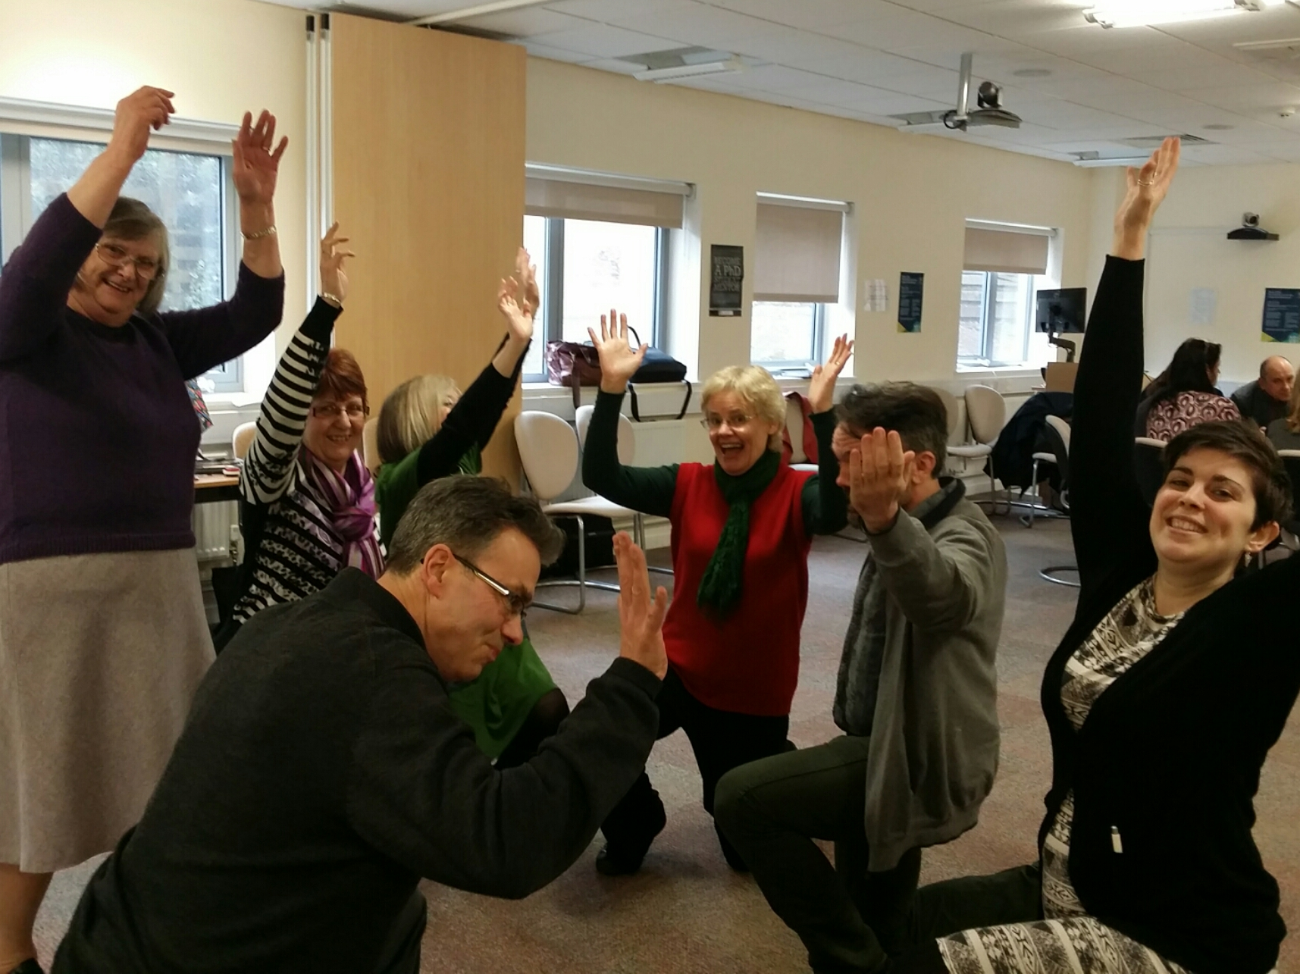
Picture 1 – Performing the cinquain poem as a group
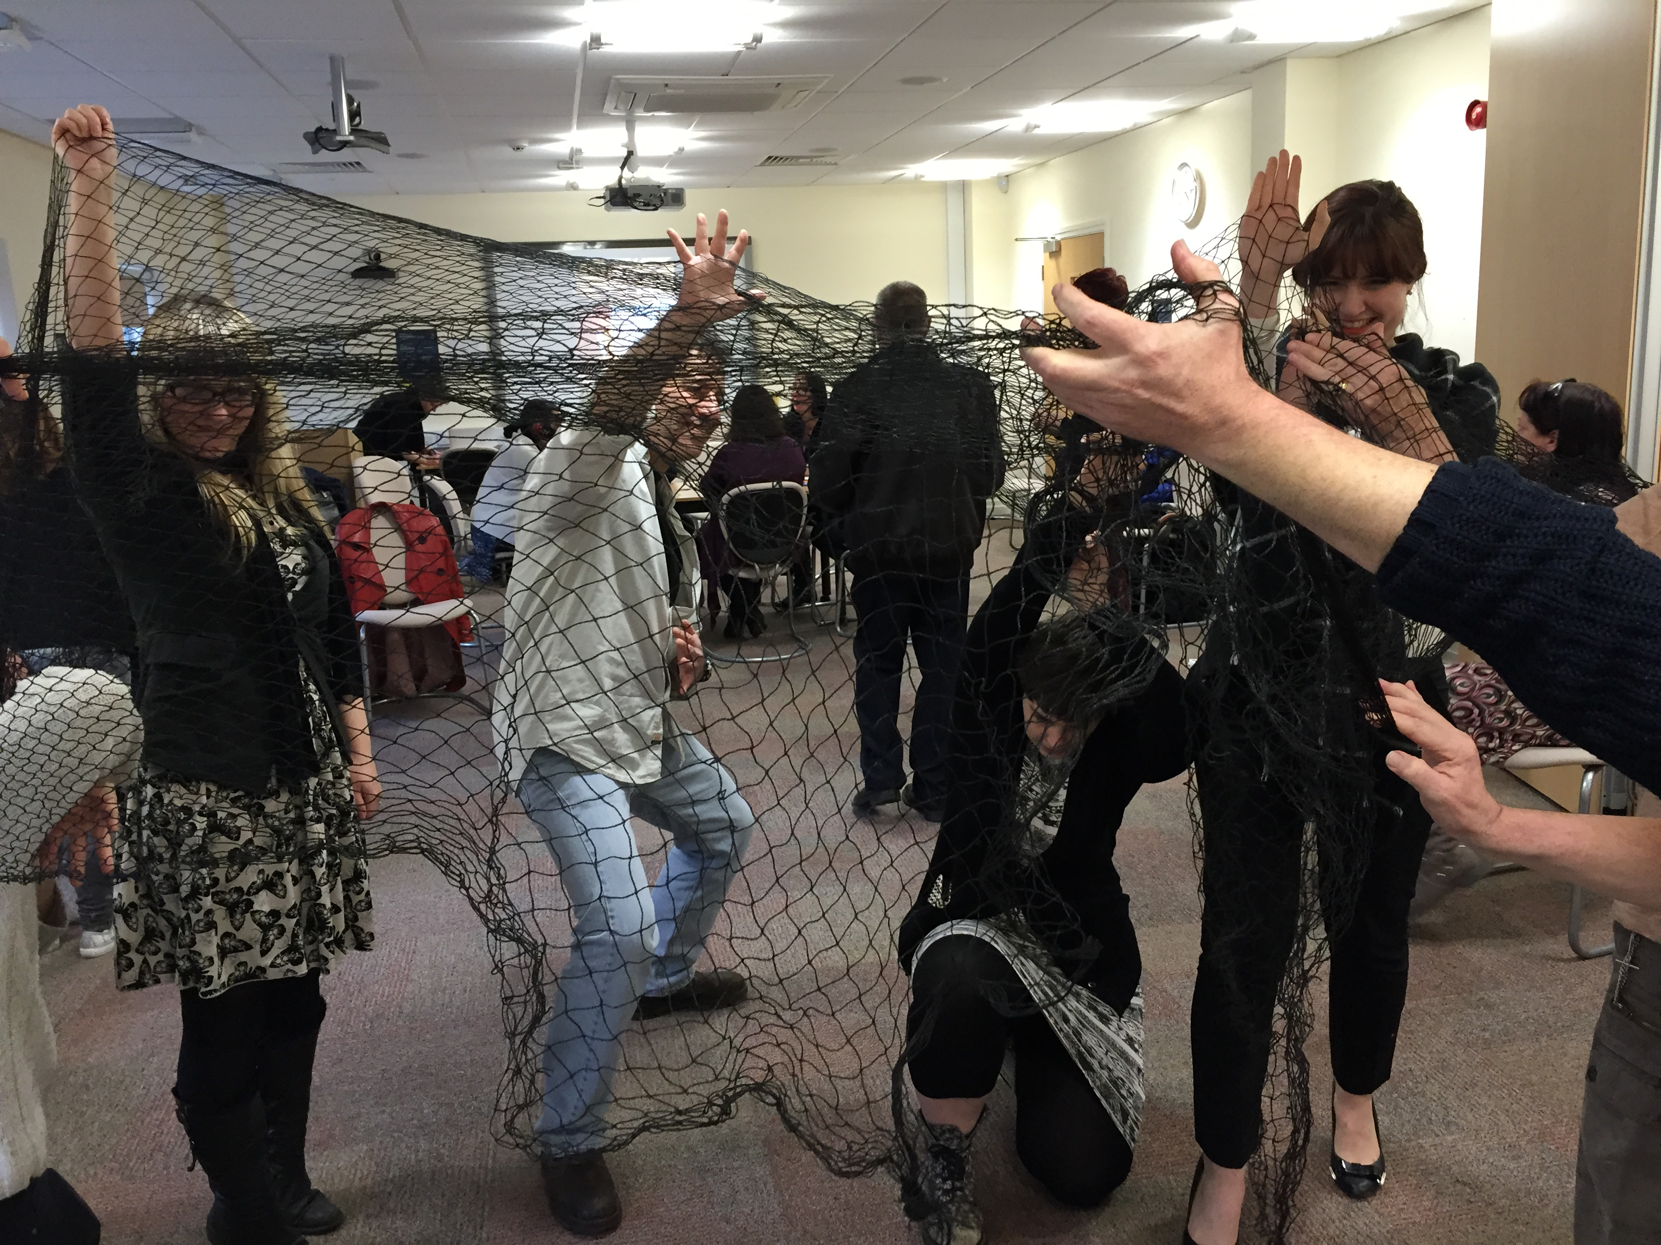
Picture 2 – Using visual aids in performance
In the process of cinquain poetry writing, the first-named author noted that the setting of the task brought people physically close together and, because nobody who participated could be described as a professional poet or actor, it effectively removed the potential for an elitist or hierarchical distinction between ‘expert’ and ‘non-expert’ (Law et al, 2011, Ostrom, 1996). Stimulating participants’ imaginations through playful exercises led to a great deal of connectivity and discussion. While the poems and performances took some people out of their ‘comfort zone’, they also acted as a leveller, creating a general feeling that “we are all in it together” (from fieldnotes). By working across professional and social distinctions, those involved in each poem group were provided with a ‘safe’ and creative space to generate and share thoughts. Importantly, very little of the emerging discussion that was observed was framed by academic discourse but instead took on the quality of common-sense analysis. Doing things differently encouraged participants to think differently and provided new opportunities to learn from one another. This emancipatory style of work was further extended in the next practical exercise.
The buttons exercise
The second cultural animation exercise which was conducted at the launch event invited people to work with buttons. Sue Moffat had initially developed this exercise as part of her fellowship with the Imperial War Museum. Over 2000 buttons of different shapes, forms and colours mixed with other small objects made up the buttons collection. It was explained to participants that the collection of buttons represented the University and its wider communities. The groups were asked to:
- Sort the buttons as ‘finely’ as possible.
- Allocate different categories to each group created
- Create a map of the relationships that exist currently
- Think about power/hierarchy/hard to reach/hidden communities
- Refine/redraw the map to create an ideal vision of the relationship
- Based on the final map write a five line Charter for CASIC
Some participants immediately sorted the buttons by colour, size and shape while others apparently chose to see them as representative of individuals or organizations (see pictures 3 and 4).
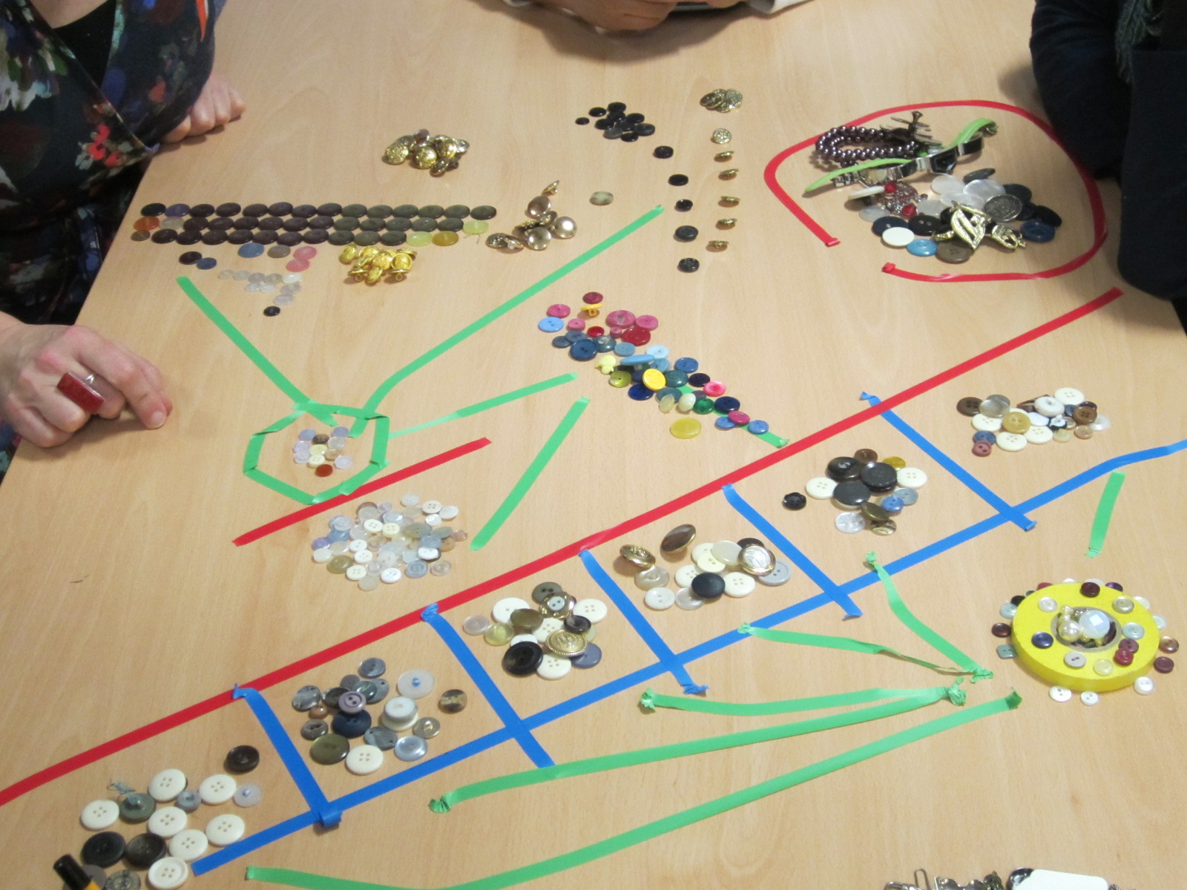
Picture 3 – sorting, allocating and mapping with buttons

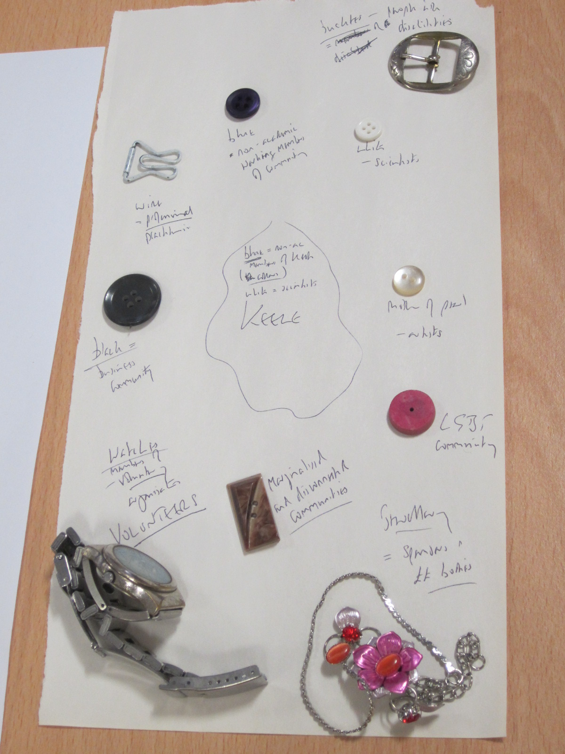
Picture 4 – Narrating accounts by arranging buttons and other objects into categories

As the exercise continued, those involved in sorting appeared to be creating narratives that emerged metaphorically from the display. For example, when explaining one button display to Sue, the participant claimed that she had made a representation of the University. She noted that this body didn’t have representatives from all communities and thus the buttons were of a similar colour and size. Sue then asked the group about the process of working to produce the ‘picture’ and participants jumped in with “eager answers” (from fieldnotes).

Zara: I tried to get clarity between buttons and non- buttons.
Katie: I collected white buttons then started sub dividing them.
Donald: I started collecting things ‘that didn’t fit in’. There are some people that don’t fit into communities and you need a different approach to help them fit in.

The role of animateur was to encourage these creative methods of sorting and, more importantly, to provide the space for participants to discuss their rationale for doing so.

Sue: All these ideas are really important because CASIC wants people to be able to research things that they are passionate about. If we look for something that we enjoy it can lead to something fantastic.

The request for participants to reflect on their passions and interests enabled a number of intriguing perspectives to emerge. For example, one non-academic participant, Donald, made the point that his buttons demonstrated a degree of power imbalance in membership of the University.

Donald: What about the people who are part of Keele who are not the academics but keep the place going? The blue buttons, blue collar workers. No-one notices if the Chief Exec doesn’t turn up for a few days but they notice if the toilet roll isn’t changed.

In extending this, Steven – another non-academic participant – wondered which buttons might best represent disenfranchised or disadvantaged groups. He picked up a set of wires and sharp objects on the button table and asked Sue whether these might be used in the display. In reply, Sue agreed that there are always people that are ‘seen as spiky/awkward individuals’ which would be well represented by the wire. She added,

The button exercise is a great way to get people to think. To think about where they fit in whether we are thinking about universities, organizations, food banks, or indeed a wide range of settings. Buttons help you to think about things. They often come to stand for ideas flowing back and forth. It is an activity designed to help you to think beyond your ‘circle’.

The use of material objects (i.e., buttons) was key to this exercise as they gave a real focus to the conversation and removed the awkwardness that can be endangered by direct questioning by the facilitator (Gubrium, et al, 2015). The buttons encouraged imagination and empathy, helping participants to get to the heart of some deeply felt views about the relationship between academia and community (Durose et al, 2014). The researcher noted that this happened ‘incredibly quickly’ (from fieldnotes). As part of the process, people co-operated, listened, assumed roles and created a dynamic that the researcher felt would not happen in a focus group or a discussion-based activity. In both these practical exercises, a ‘dialectics of collaboration’ rather than ‘data gathering’ underpins the approach (Gubrium, et al. 2015). By this we mean that these are not ‘methodological tactics’ designed strategically to gain entry to difficult communities and to find out what members of such communities think without asking them direct questions. Rather, the examples cited here are rooted in an emancipatory approach to research which interrogates the very notion of community itself; who is inside it, who outside it and why? They ask how knowledges come about, how they might be adapted and evolved in participatory exercises.
As to how this is done, we have (albeit briefly) shown how the interaction between the participants and the animateur prepares the ground for a productive cycle of reflection, analysis, metaphor and representation, discussion and revision. This is designed to stimulate discursive traffic between academics and non-academics, to enable people from varied backgrounds to approach a particular problem, question or dilemma in a way that does not rely on debate and confrontation. In emphasising focus upon the practicalities of poem-writing, for example, we see how various actors might explore issues of power collaboratively by drawing on their different skills and ways of seeing the world to add words onto paper. The outcome takes ‘real world’ form as a meaningful poem or a button picture. And while such forms may seem, at first glance, to be somewhat arbitrary or even juvenile in their simplicity, it is precisely this which enables the collaboration to become powerful and encouraging. This playful approach aims to give voice, space and time to those who are often excluded from formal research agendas as ‘outsiders’; that is non-experts. In a practical sense, this is how cultural animation aims to ‘flatten’ the hierarchy between a number of social actors and thus better reveal the nuances of a number of difficult social problems by working from ‘bottom up’. At the very least, we feel that such an approach has the potential to increase social respect for other people and to raise the profile of their distinctive lives and problems. In the discussion section which follows, we consider some of the theoretical and philosophical underpinnings of this approach.
Discussion: Co-creating experience and knowledge
The starting point in most social scientific research is a problematic situation (Dewey, 1938 [1991]) because social science does not have a privileged access to reality and it always has to go back to the immediate qualitative experience (Biesta and Burbules, 2003). Hence, social problems and dilemmas are usually essential for framing research questions and designing methodological approaches. They provide the ‘so what?’ impulse which drives enquiry onward and, in participating with cultural animation exercises such as those we have outlined, we can see that even the most creative methodological approaches require this stimulus. First-hand observations of cultural animation work suggest that experience is not antithetical to knowledge; rather, that knowledge is part of experience and contributes to its enhancement. As such, experience is both embodied and rational, it is both thought and action.
In taking this approach, we argue that cultural animation – like participatory action research - is heavily influenced by American Pragmatism and Dewey’s principle of the experimental iteration. This suggests that a hypothetical solution to a problem is formulated and tried out, its level of success monitored, the proposed solution reformulated in light of this, the new strategy tried out, and so on. Dewey’s theory of knowledge underlines the indefinite nature of social interaction, knowing as a mode of experience, and the relationship between actions and consequences (Kelemen and Rumens, 2013). Thus, the theoretical approach we take here regards knowledge as a series of practical acts judged by their consequences.
Moreover, all judgments are practical in as much as they originate from an incomplete or ambiguous practical situation which is to be resolved. In taking this tack, our suggestion is that the aim of knowledge is not to correspond to the world but to anticipate (and perhaps influence) future experience, taking as its material experiences the present and the past (Mounce 1997). In this context, the apparent ‘truthfulness’ of knowledge is ultimately assessed by its usefulness, for if people do not find ideas useful for some purpose, they will simply discard them. For Dewey, thinking and acting are just the two names for the same process, the process of making our way as best we can in a universe shot through with contingencies and ambiguities (Menand 2001). The experience of (and active influence over) uncertainty, ambiguity and useful knowledge underpins the cultural animation approach. This is because what participants know about the world is influenced by what they do, can do and want to do in the world, as individuals and as collectivities.
Importantly, from our perspective, knowledge is not an individual achievement but a social one. Moreover, we feel any research enquiry must be embodied if it is to be able to cope effectively with the perennial indeterminacy and contingency with which humans have to struggle in their everyday existence. There are, of course, approaches other than cultural animation which seek to do this (ethnography, in particular). John Dewey puts it thus:
‘The senses are the organs through which the live creature participates directly in the on goings of the world around him. In this participation the varied wonders and splendour of this world are made actual for him in the quality he experiences…’ (1934: 22).
For Dewey, to think means to experience the world in one way or another and not accounting for this experience means escaping into abstract and useless theory. Experience means not only what had happened in the past but our visceral and embodied response to the immediate context. In Experience and Nature (1925: 8), John Dewey argues that experience is about what ‘men (sic) do and suffer, what they strive for, believe and endure, and also how men act and are acted upon, the ways in which they do suffer, desire and enjoy, see, believe, imagine...’ . Cultural animation makes this embodied experience central to the process of knowledge co-creation.
The process of creativity and collaboration present in cultural animation aims to shed artistic and graphic light on particular issues to transform an individual or group’s way of seeing the world; the ways they individually and collectively know what is ‘going on’. The re-learning/re-viewing of issues at hand means they can be experienced and viewed differently and, thus, thought of differently. As to how this shift in thinking happens in practical terms, it is well documented in the arts-based methodology literature (Barry and Meisiek, 2010; Sutherland, 2012; Taylor and Ladkin, 2009) that people think and behave differently when then get up, move about, engage in physical interactions and make objects together compared to situations in which they sit and talk to each other, be it in interviews or focused group situations. This is because if communication takes place only through narration, people who do not have the necessary cultural resources to make a convincing case, tend to remain silent or become very conscious of their own limitations.
While critics may point out that cultural animation is a form of play, we’d like to point out that “you can discover more about a person in an hour of play than in a year of conversation” (Plato quoted in D’Angour, 2013: 296). In this way, cultural animation is linked to problem solving in a rather innovative (and playful) way because it complicates the very idea of significant research problems just as it challenges traditional methods for tackling them. By this we do not mean, in the narrow positivist sense, of using a method to arrive at fixed and certain ‘solutions’. Some problems, after all, are not easily solvable for they may be wicked (Rittel and Webber, 1973) and, therefore, escaping definitive definitions and ultimate solutions as well as the logic of cause-effect.
To return, for a moment, to the question of impact, our argument here is that because cultural animation helps create new forms of knowledge, ways of thinking about things and active collaborations, as an approach to social science research it has the potential for a longer term legacy than the ‘quick fix’ of impact. Donna Haraway’s concept of ‘situated knowledge’ (1988:592) is helpful here. Haraway argues that situated knowledges are culturally specific, located in particular groups and communities and to gain access to them, one needs to resist the urge to ‘close off the dialectic’ between research participant and author. Using the creative approach of poems and pictures, for example, those cast in the traditional role of researcher gain a degree of immersive, embodied experience of other peoples’ ‘situated knowledges’. Those traditionally ‘outside’ academia get a powerful voice and are able to exert some control over the process of artefact-making. Importantly, then, the knowledges that are created through action, reflection and discussion during the experience of cultural animation, evade the traditional approach of ‘writing up’ empirical findings into articles and books. Instead, following Haraway, we might see that knowledge is accessible to all participants, it can be challenged and revised and is evident in the physical forms produced in such creative exercises, rather than in datasets of empirical findings.
We can describe a number of reasons why cultural animation might form a valuable means of fostering research within existing frameworks of ‘impact’ (Pettigrew, 2011), specifically, the conceptual impacts in the generation of original knowledge, understanding or awareness among potential audiences and users of research findings, including policy-makers. Further, the examples we have sketched out show the potential for connectivity impacts to be reflected in knowledge exchange activities and the establishment of working links between ‘knowledge producers’ (ibid. 350) in and outside universities. But we also feel that these strengths take us beyond existing notions of impactful research. Our contention here is that first, cultural animation presents a novel and practical platform for physical and intellectual engagements between scholars, practitioners and community members and helps re-conceptualise what is meant by academic method, expertise and knowledge. Second, it offers researchers a practical way of managing the co-production of knowledge, disassembling some of the inherent/inevitable power imbalances between ‘researchers’ and ‘subjects’ and reflecting a much broader range of ‘situated knowledges’ (Haraway, 1988). Further research is needed to grasp the full significance of this as well as to test out the longer-term effects of cultural animation on those who participate. The value of this work would add much to the emerging discourse of ‘impact’ and may help to re-frame it in more sympathetic and sophisticated terms.
Conclusion: Thinking beyond our circles
Those interested by the sorts of techniques that we have described here are working hard to initiate an important conversation about the way in which social research methods are invented, travel and have effects in the world. The cultural animation techniques that we have described and theorized in the foregoing analysis offer a practical way to access some, if not all, of what Pettigrew (2011) describes as the five categories of impactful research: ‘Instrumental, conceptual, capacity building, cultural change, and enduring connectivity impacts’ (p. 350) We have shown two brief examples of the ways in which members of CASIC are working to enable academics to harness creativity to potentially powerful effects within communities. This, we argue, makes a significant – if exploratory -contribution to the ways in which impact can be considered and reconsidered.
As we explained in the case of the cinquain and button experiments, the aim of the inquiry and the research questions develop out of the convergence of theory and of practice. When such methods work well, both sides benefit from the research process. Non-academics are able to introduce and discuss the ways they deal with the existential challenges of everyday life while researchers are better able to step back from familiar literatures, ways of writing and their attendant power relationships in order to connect meaningfully with those ‘beyond the circle’.
We stated at the outset that any contribution to the impact agenda should begin by questioning the term ‘impact’ itself. In concluding this working paper, we reflect openly on that word and support Briggle et al’s argument (2015) that the word ‘impact’ is a dubious choice of metaphor in the first place. Briggle et al suggest that terms like ‘effect’, ‘influence’ or ‘inflect’ better represent the complex processes involved. We suggest that ‘co-production’ is of more pressing significance (Durose, 2014). In taking this tack, we suggest that it is difficult (if not impossible) to measure the ‘impact’ of research in the same way that we can measure the impact of a solid object hitting another. Some co-creative effects and transformations unfold over very long time horizons and work deep underground in the roots of a group or community’s culture. And while we are mindful of the pressing need for research into these long term processes, it is our contention that ‘legacy’ may be a more useful term than ‘impact’.
By legacy we mean something left behind for others to use or think about while they engage in their own practices. As such, legacies can be intended or unintended, tangible or intangible, positive or negative. The idea of research legacies is a helpful concept for broadening out conversations around impact, so that researchers can consider and be practical about what we might leave behind for others to benefit from: for instance tangible legacies such as research papers, assets, artefacts and other resources that are re-usable, or more intangible legacies such as changes in attitudes and culture, new connections and working relationships, new ideas that others may build on or practices which they may adopt. It does not sit well to ‘measure’ these effects in metric terms. As Grishin observes, ‘uncertainty is closely linked with creativity’ (Grishin 2008:115), and there is a delicate balance to be struck between generic principles and the situated perspectives that advanced methods demand (Kara, 2015). After all, every set of metrics is full of interpretive moments and erasing these from the picture in a spurious attempt at being ‘scientific’ is to devalue the benefits and subtleties of participatory and embodied research approaches. A reiterated philosophy of impact (whether we re-name this legacy or not) must, therefore, also consider broader and more diffuse influences across long timelines. We suggest that it should also consider the intertwining, complex and often contradictory nature of knowledge itself. We should think about the reasons we want to have impact rather than merely how it can be achieved and measured. This, we argue, will bring us into closer contact with the bigger social questions of justice, voice, inclusion and social interaction.

References

Barone, T. and Eisner, E (1997) Arts-based educational research. In R. Jaeger (Ed.), Complimentary methods of educational research (pp. 95-109). New York: Macmillan
Publishing.
Barry D and Meisiek S (2010) Seeing More and Seeing Differently: Sensemaking, Mindfulness and the Work-Arts. Organization Studies 31(11): 1505-1530.
Biesta, G. and Burbules, N. (2003) Pragmatism and education research. Michigan: Rowman and Littlefield publishers, Inc.
Brearley, L. and Darso, L. (2008) Business studies : vivifying data and experience through artful approaches. Handbook of the arts in qualitative research: perspectives, methodologies, examples, and issues. ed. / Gary J. Knowles; Ardra L. Cole. P. 720. Thousand Oaks, California : Sage Publications.
Briggle, A. Frodeman, R and Holbrook, B. (2015) The Impact of Philosophy and the Philosophy of Impact: A guide to charting more diffuse influences across time. Blog post, London School of Economics at: http://blogs.lse.ac.uk/impactofsocialsciences/2015/05/26/the-impact-of-philosophy-and-the-philosophy-of-impact/ [last accessed 11/09/15]
Chevalier, J.M. and Buckles, D.J. (2013) Participatory Action Research: Theory and Methods for Engaged Inquiry, Routledge UK.
Christ (2010) Teaching mixed methods and action research: Pedagogical, practical and evaluative considerations. In Tashakkori A., Teddlie C. (Eds.), Handbook of mixed methods in social & behavioural research (2nd ed., pp. 643-676). Thousand Oaks, CA: Sage.
Christ, T. (2012a) Grant funding strategies for action research designs. Paper presented at American Education Research Association, Vancouver, British Columbia, Canada.
Christ T. and Elmetaher H. (2012). Research teaching pedagogy: Lessons learned from an Arabic language intervention pilot study. Research in Schools, 19, 62-75.
Collins, H. and Evans, R. (2007) Rethinking Expertise Chicago: University of Chicago Press.
Collins, H.M. and Evans, R.J. (2002) The Third Wave of Science Studies: Studies of Expertise and Experience Social Studies of Science 32 (2), 235-96
D’Angour, A. (2013), Plato and Play: Taking Education Seriously in Ancient Greece, American Journal of Play, 5/3, 293-3017
Daghighi Latham, S. Leadership Research: An arts-informed perspective Journal of Management Inquiry 23(2): 123-132.
Dewey, J. (1925[1981]). ‘Experience and nature’, in J. A. Boydston (ed.), Later Works 1, Carbondale & Edwardsville: Southern Illinois University Press.
Dewey, J. (1934[1987]). ‘Art as experience’, in J. A Boydston (Ed.), Later Works 10, Carbondale & Edwardsville: Southern Illinois University Press.
Dewey, J. (1938 [1991]). ‘Logic: theory of inquiry’, in J. A. Boydston (ed.), Later works 12. Carbondale & Edwardsville: Southern Illinois University Press.
Drath, W. and Palus, C. (1994) Making Common Sense: Leadership in a Community of Practice CCL report number 156. Center for Creative Leadership.
Durose, C., Beebeejaun, Y., Rees, J. and Richardson, L. (2014) ‘Public value or public harm? towards co-production in research with communities’, Environment and Planning 31
ESRC (1994), Building Partnerships: Enhancing the Quality of Management Research. Swindon: Economic and Social Research Council.
Fischer, F. (2000) Citizens, Experts, and the Environment: The Politics of Local Knowledge Duke University
Gauntlett, D. (2007) Creative Explorations: New approaches to identities and audiences London: Routledge.
Grishin, S. (2008) Uncertainty as a Creative Force in Visual Art in Uncertainty and Risk: Multidisciplinary Perspectives (2008), Bammer, G. and Smithson, M. (eds), Earthscan Risk in Society Series, London, 382pp.
Gubrium, A., Harper, K. and Otanez, M. [eds.] (2015) Participatory Visual and Digital Research in Action Walnut Creek, CA: Left Coast Press.
Hand, M and Hillyard, S. (2014) Big Data? Qualitative approaches to digital research London: Emerald.
Haraway, D. (1988) Situated Knowledges: The Science Question in Feminism and the Privilege of Partial Perspective Feminist Studies 14 (3): 575-599.
Hine, C. (2000) Virtual Ethnography London: Sage.
Kara, H. (2015) Creative Research Methods in the Social Sciences: A Practical Guide. London: Policy Press.
Kelemen, M. and Rumens, N. (2013) American Pragmatism and Organization: Issues and Controversies Surrey: Gower.
Law, J., Ruppert, E. and Savage, M. (2011) The Double Social Life of Methods CRESC Working Paper Series Working Paper No. 95 CRESC, Open University
Meagher, L. R. (2009). ‘Impact evaluation of the PACCIT programme’. Unpublished report prepared for the Evaluation Committee of the ESRC.
Menand, L. (2001) The Metaphysical Club: A Story of Ideas in America, New York: Farrar, Sraus and Giroux
Mounce, H. O. (1997) The Two Pragmatisms: From Pierce to Rorty, London: Routledge
Ostrom, E. (1996) Crossing the great divide: Coproduction, synergy, and development World Development 24(6): 1073-1087
Pettigrew, A. M. (2011), Scholarship with Impact. British Journal of Management, 22: 347–354.
Prosser, J. and Loxley, A. (2008) Introducing Visual Methods NCRM Methodological Review Paper Discussion Paper 010.
Reason, P. and Bradbury, H. (2008) (eds) The Sage Handbook of Action Research: Participative Inquiry and Practice. Sage, CA.
REF Assessment Framework (2011) Decisions on assessing research impact Higher Education Funding Council for England, Scottish Funding Council, Higher Education Funding Council for Wales, Department for Employment and Learning, Northern Ireland. Accessed at http://www.ref.ac.uk/pubs/2011-01/ [last accessed 14/9/15].
Reynolds, P. (1984) Cultural Animation: "Just plain folks" building culture -- rather than just consuming it. Art And Ceremony In Sustainable Culture 5:32.
Rittel H and Webber M (1973). Dilemmas in a General Theory of Planning. Policy Sciences 4: 155-169.
Romme, A. G. L., Avenier, M.-J., Denyer, D., Hodgkinson, G. P., Pandza, K., Starkey, K. and Worren, N. (2015), Towards Common Ground and Trading Zones in Management Research and Practice. British Journal of Management, 26: 544–559.
Roos, J., and Victor, B. (1998) ‘In Search Of Original Strategies: How About Some Serious Play?’ IMD Perspectives for Managers (26) 15
Sutherland I. (2012) Arts-Based Methods in Leadership Development: Affording Aesthetics Workspaces, Reflexivity and Memories with Momentum. Management Learning 44(1): 25-43.
Taylor S. S. and Ladkin D (2009) Understanding Arts-Based Methods in Managerial Development. Academy of Management Learning and Education 8(1): 55-69.
Taylor, C. and Coffey, A. (2009) Editorial/ Special Issue: Qualitative research and methodological innovation Qualitative Research 9(5): 523-526.
Thrift, N. (2000) ‘Non-representational theory’ in: Johnston, D., Gregory, D., Pratt, G. and Watts,M. (eds) The Dictionary of Human Geography, 4th Edition, Blackwell, Oxford
Travers, M. (2009) New methods: old problems: A sceptical view of innovation in qualitative research Qualitative Research 9(2): 161-179
Van Maanen, J. (1979). “Reclaiming Qualitative Methods for Organizational Research: A Preface.” Administrative Science Quarterly 24(2):520-526.
Van Maanen, J. (1988). Tales of the Field: On Writing Ethnography. London: University of Chicago Press.
Warren, S. (2012) ‘Qualitative, Participatory Visual Methods’ in C. Cassell & G. Symons (eds) The Practice of Qualitative Organizational Research: Core Methods and Current Challenges, London: Sage pp. 275-295
Wiles, R. Bengry-Howell, A. Crow, G. and Nind, M. (2013) But is it innovation? The development of novel methodological approaches in qualitative research in Methodological Innovations Online 8(1): 18-33.
Xenitidou, M. and Gilbert, N. (2012) Introduction to the special issue: The process of methodological narrative accounts and reflections Methodological Innovations Online 7(1): 1-6.

Biographical Note
Mihaela Kelemen is Director of the Community Animation and Social Innovation Centre (CASIC). (More details about CASIC can be found at www.keele.ac.uk/casic) She holds a PhD in applied economics from the Academy of Economic Studies, Bucharest and a DPhil in Management Studies from Oxford University. Mihaela came to Keele in 1996 and was promoted to Chair in 2006. She is currently Principal Investigator on three AHRC grants and co-investigator on one AHRC grant and on one ESCR seminar series grant. She can be contacted at m.l.kelemen@keele.ac.uk.
Lindsay Hamilton is Lecturer in Management at Keele University and Director of Undergraduate Studies for Management and International Business. She is Book Reviews Editor of the Sage journal, Ethnography (http://eth.sagepub.com/), a member of the Community Animation and Social Innovation Centre at Keele (CASIC) and chief editor of the Working Paper Series. She can be contacted at l.hamilton@keele.ac.uk.

